Exercise: Web Service Introduction
Problems for exercises and homework for the "Back-End Technologies Basics" Course @ SoftUni.

Music App
Initial Instructions for Music App
Prerequisites
Installed Docker: https://www.docker.com/
Steps to Use Music App
1. Download the music-app.zip file, which contains all the necessary files.
2. Unzip the music-app.zip file into your preferred directory on your machine.
3. Build and Run the Docker Containers.
Ensure you have Docker and Docker Compose installed.
Then, run the following command to build and start the containers:
docker-compose up --build
This command will load the Docker image into your local Docker environment.
4. Access the API
Once the containers are up and running, you can access the API at http://localhost:3030
5. API Documentation
API documentation is available at http://localhost:3300/api-docs

Register a New User
- Locate POST /users/register :
- In Swagger UI, find the section or tab that contains POST /users/register
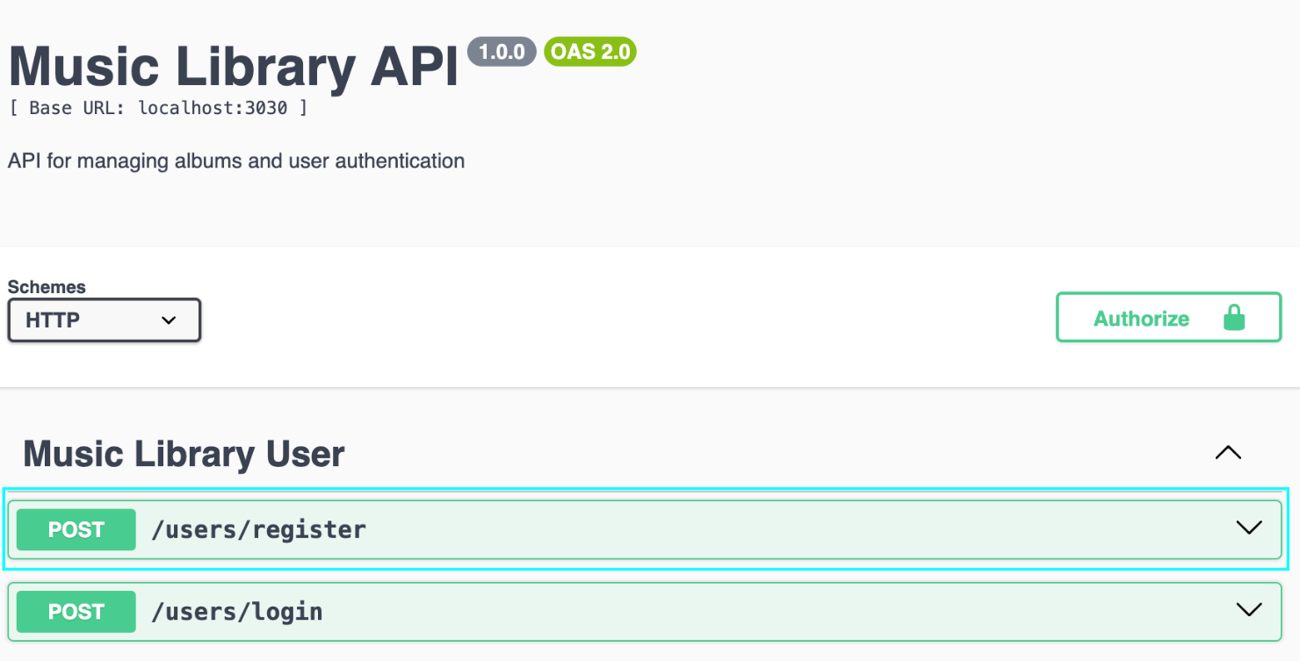
- Expand POST /users/register :
- Click on the POST /users/register method to expand the section and view the request form.
- Fill in the form:
- Enter the required information for the new user:
  - email: user@example.com (or another valid email address)
  - password: password123 (or another password)
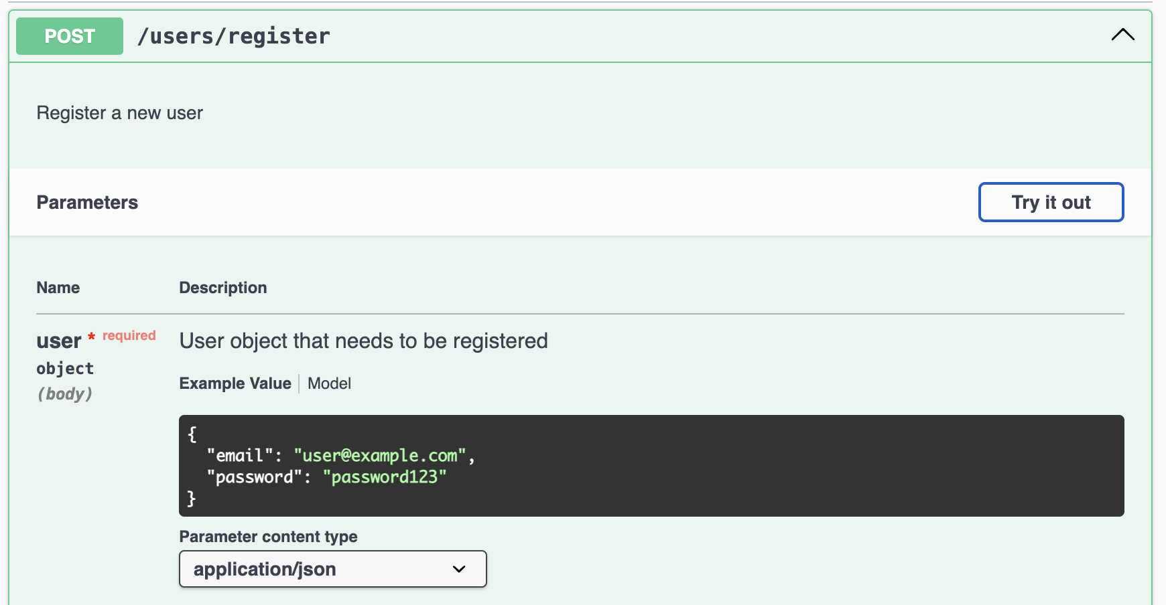
- Send the request:
- Click the Try it out button and then click Execute to send the request to the server.
- Review the response:
- Swagger UI will display the results of the request:
  - If successful (status code 200), you will see details of the new user.
    - Upon successful login or registration (HTTP Status 200), you will receive a token in the response.
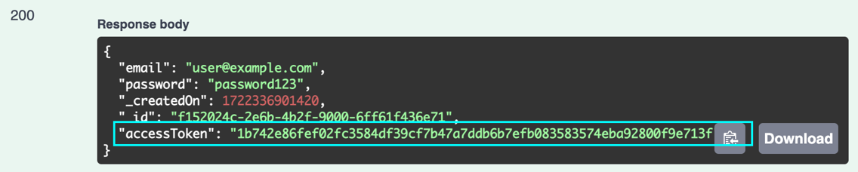
    - This token is required for authenticating requests to protected endpoints.
    - Please use this token to authorize your API requests.
  - If there is an error (status code 400 or 409), you will see the corresponding error message.
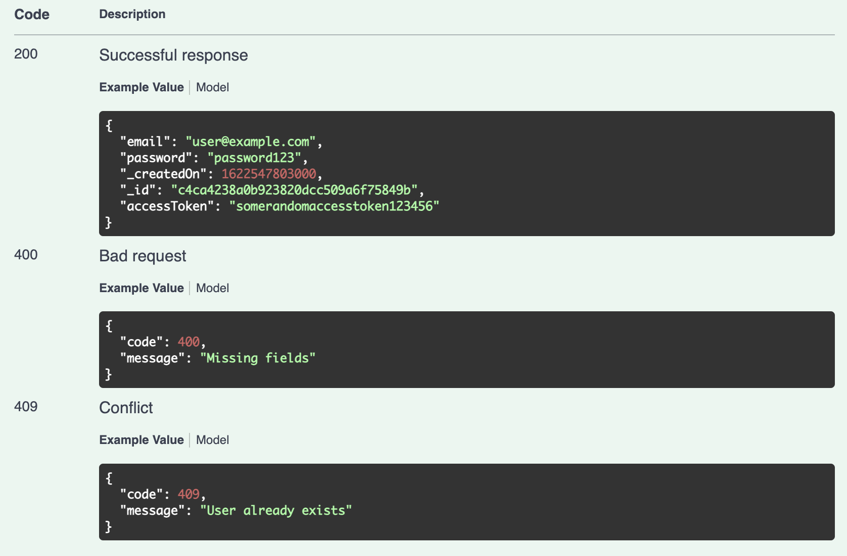

Login a User
- Locate POST /users/login :
- In Swagger UI, find the section or tab that contains POST /users/login
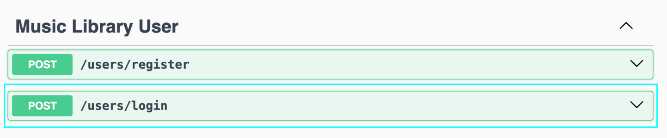
- Expand POST /users/login
- Click on the POST /users/login method to expand the section and view the request form.
- Fill in the form:
- Enter the login details:
  - email: user@example.com (or another valid email address)
  - password: password123 (or another password)
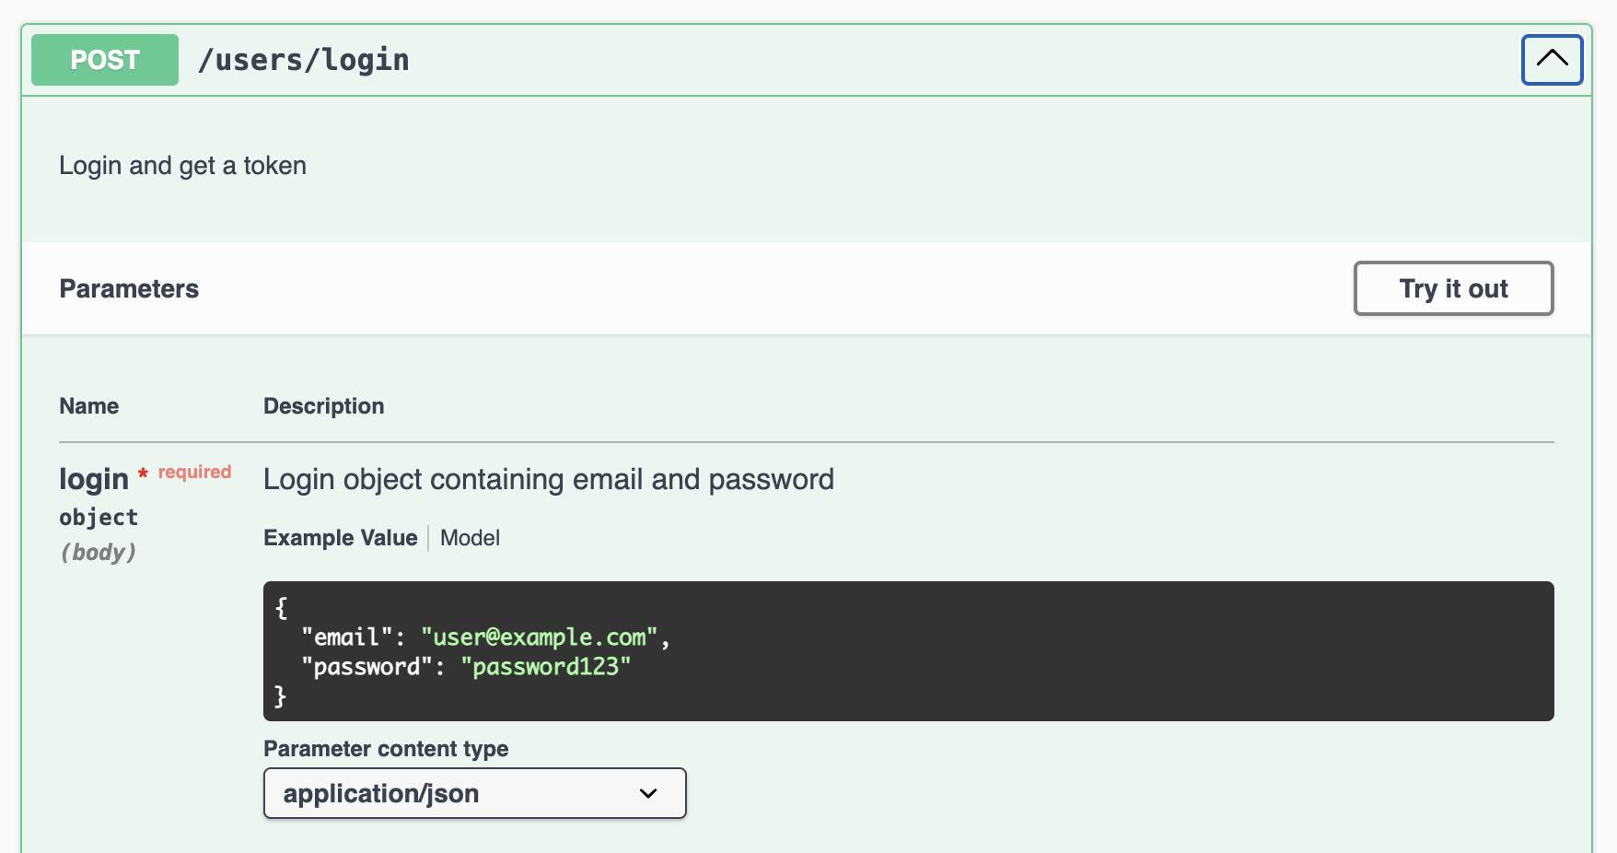
- Send the request:
- Click the Try it out button and then click Execute to send the request to the server.
- Review the response:
- Swagger UI will display the results of the request:
  - If successful (status code 200), you will see details of the new user.
    - Upon successful login or registration (HTTP Status 200), you will receive a token in the response.

    - This token is required for authenticating requests to protected endpoints.
    - Please use this token to authorize your API requests.
  - If there is an error (status code 403 or 500), you will see the corresponding error message.
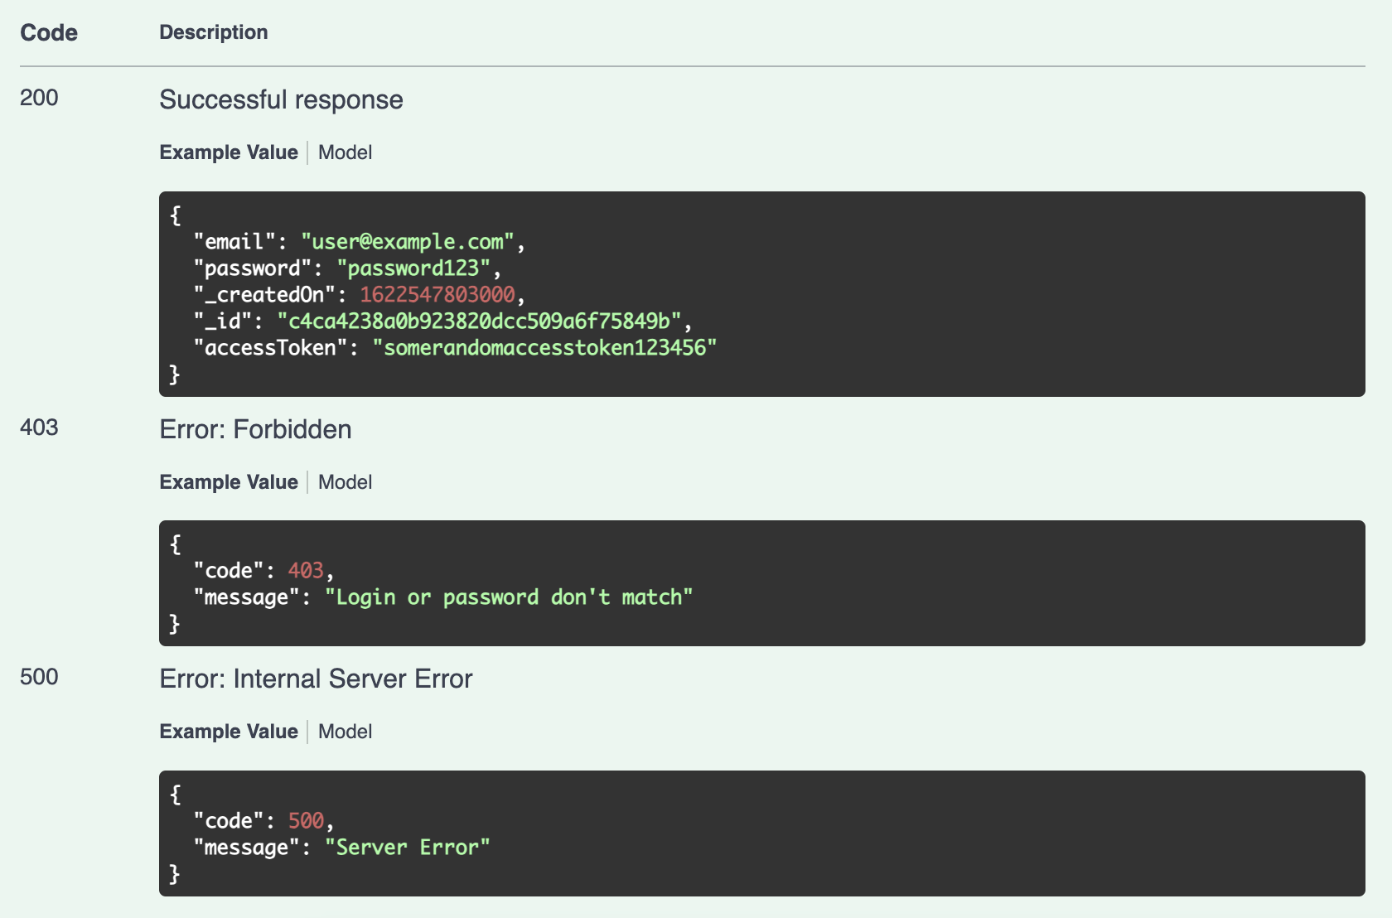

How to Authenticate in Swagger UI?
Before making authenticated requests, ensure you have a user token. This token is obtained through the login or registration process.
- In Swagger UI, find the Authorize button. This button is usually located in the top-right corner of the Swagger UI interface.
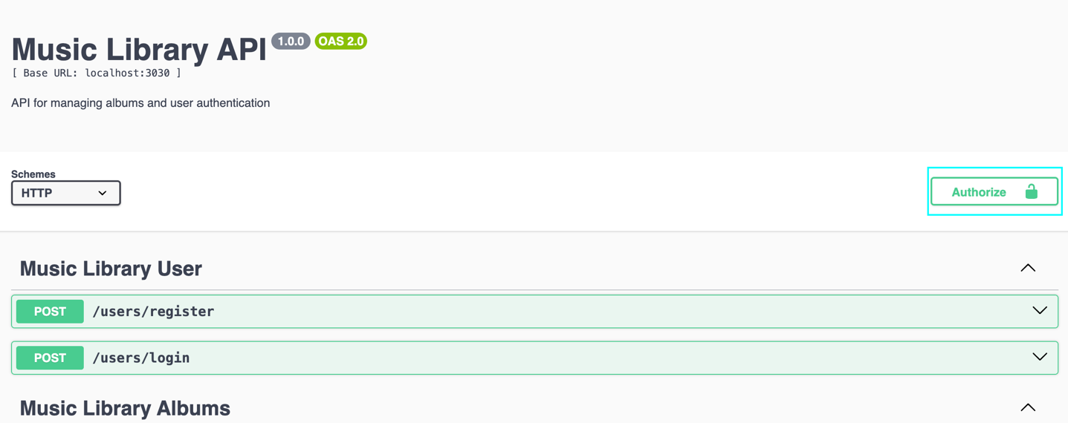
- Click the Authorize button to open the authentication dialog.
- In the dialog that appears, you will see an input field labeled "Value”.
- Enter the user token you obtained during login or registration in this field.
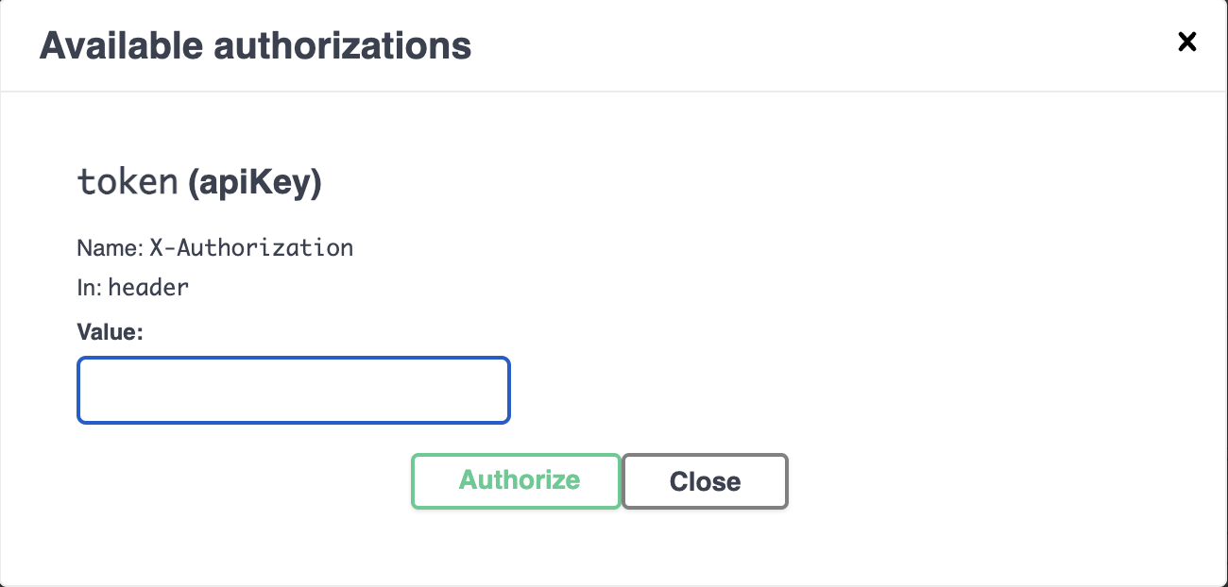

- Click the Authorize button within the dialog to submit the token.
- After submitting the token, close the authorization dialog.

Now you are authorized!
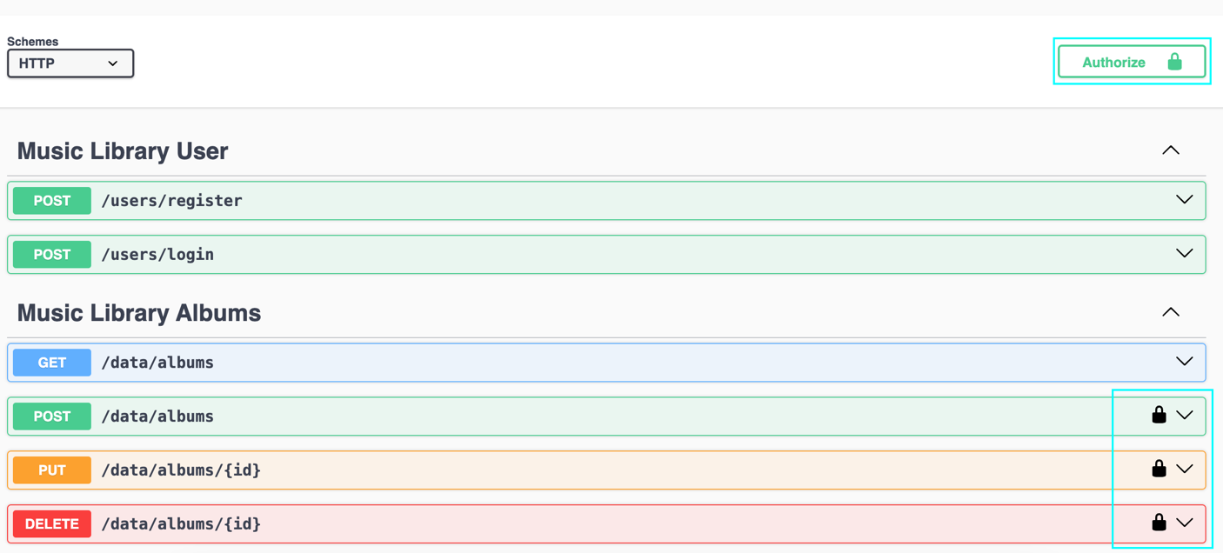

List All Albums
- Locate GET /data/albums :
- Find the GET /data/albums endpoint in the Music Library Albums section.
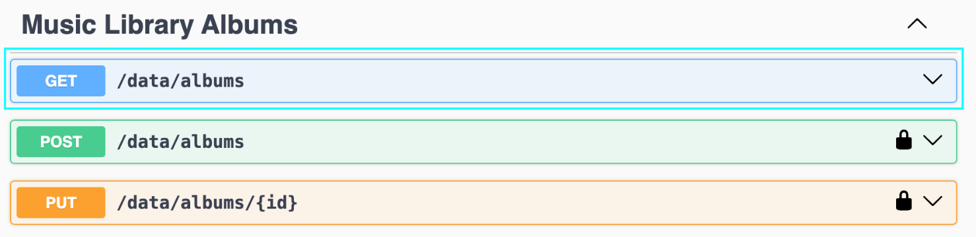
- Expand GET /data/albums :
- Click on the GET /data/albums method to reveal the request options.
- Add Query Parameter (optional):
- If you want to sort albums, enter query parameter in the sortBy query parameter field.
  - The query parameter for the endpoint can be any of the album properties, such as singer, album, imageUrl, label or sales.
  - For instance, if you want to filter albums by the artist's name, you could use the singer query parameter.
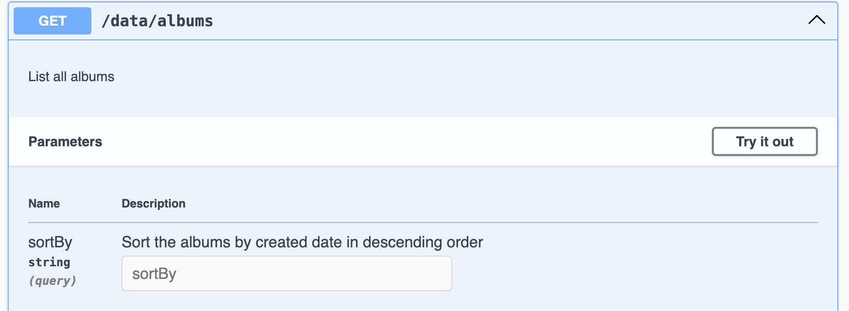
- Send the request:
- Click the Try it out button and then click Execute to send the request to the server.
- Review the response:
- Swagger UI will display the results of the request:
  - If successful (status code 200), verify that the list of albums is displayed correctly.
  - If there is an error (status code 400), review the error message for details.
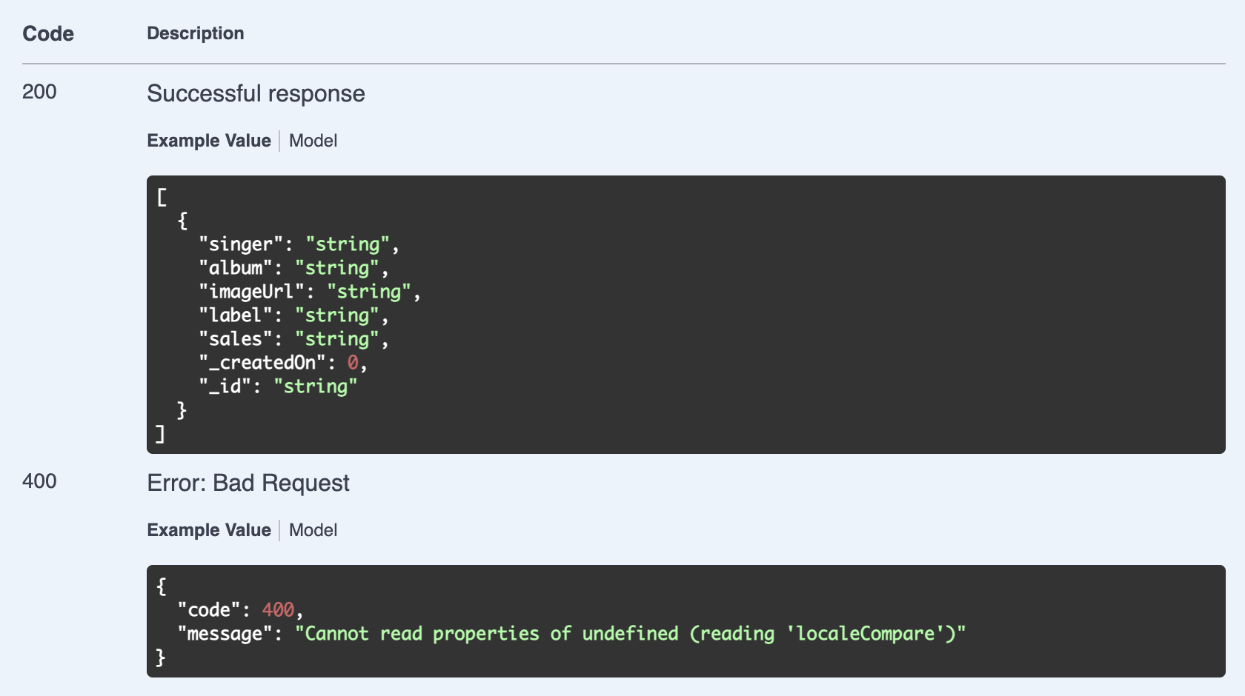

Create a New Album
Authentication Required: This endpoint requires a valid user token. Please ensure you are authenticated by providing a token obtained from the login or registration process.
1. Locate POST /data/albums :
- Find the POST /data/albums endpoint in the Music Library Albums section
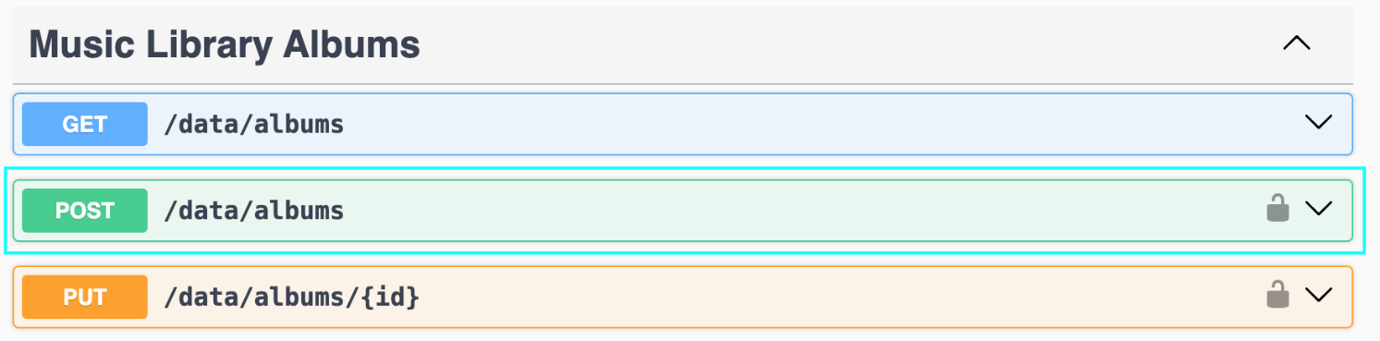
2. Expand POST /data/albums :
- Click on the POST /data/albums method to reveal the request options.
3. Fill in the Request Body:
- Enter the details for the new album:
  - singer: Artist Name
  - album: Album Title
  - imageUrl: http://example.com/image.jpg
  - label: Record Label
  - sales: 1000
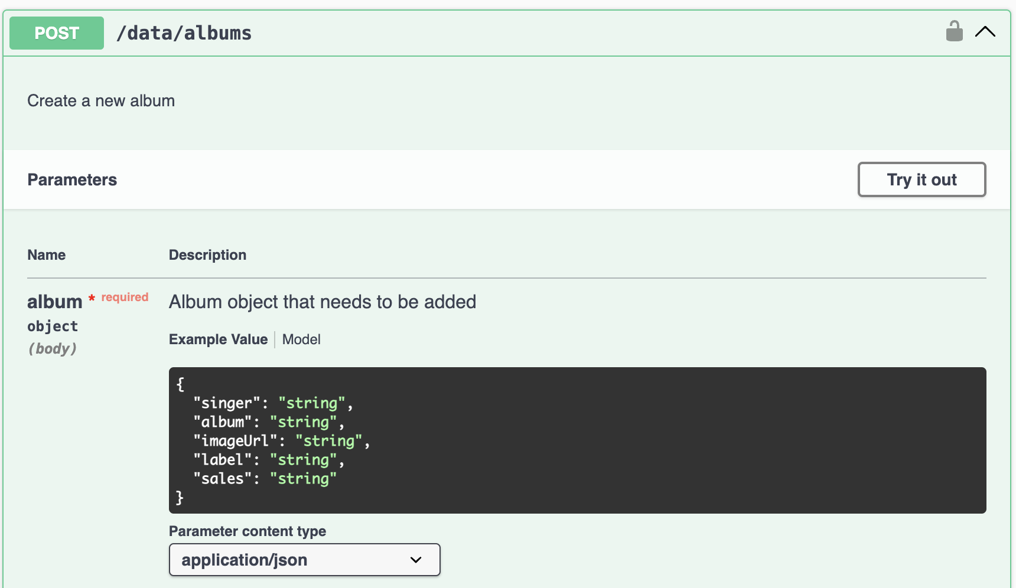
4. Send the request:
- Click the Try it out button and then click Execute to send the request to the server.
5. Review the response:
- Swagger UI will display the results of the request:
  - If successful (status code 200), verify that the new album details are correctly displayed.
  - If there is an error (status code 401), ensure that your authentication token is correct and retry.
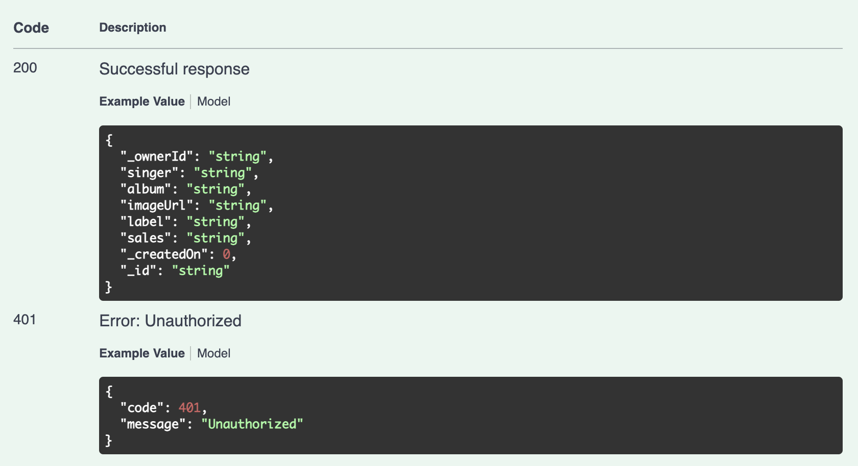

Get an Album by ID
1. Locate GET /data/albums/{id} :
- Find the GET /data/albums/{id} endpoint in the Music Library Albums section.
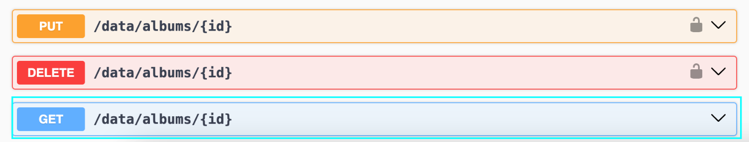
2. Expand GET /data/albums/{id} :
- Click on the GET /data/albums/{id} method to reveal the request form.
3. Enter the Album ID:
- Input the ID of the album you wish to retrieve in the id path parameter field.
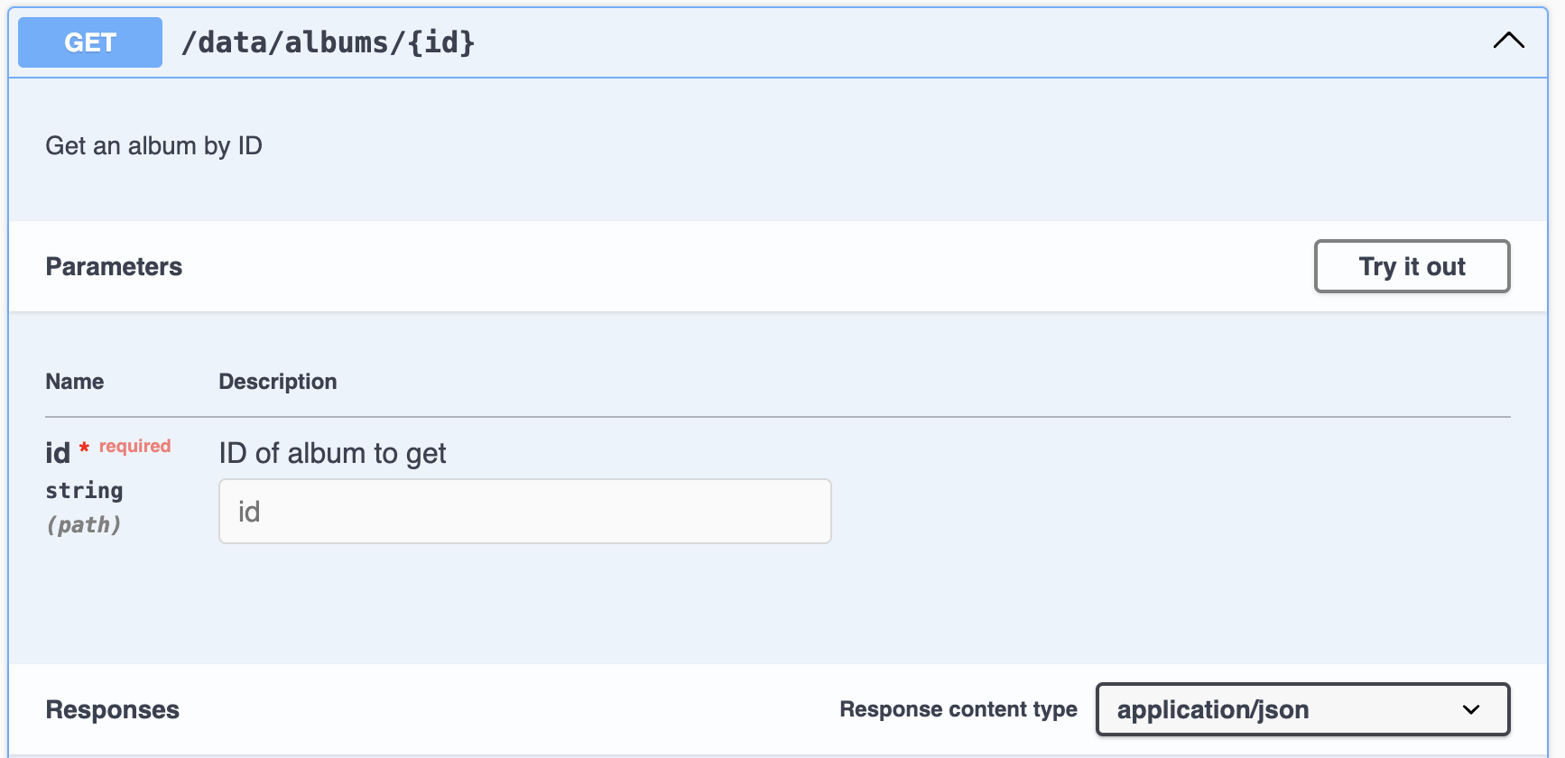
4. Send the request:
- Click the Try it out button and then click Execute to send the request to the server.
5. Review the response:
- Swagger UI will display the results of the request:
  - If successful (status code 200), verify that the album details are correctly displayed.
  - If there is an error (status code 404), review the error message for details.
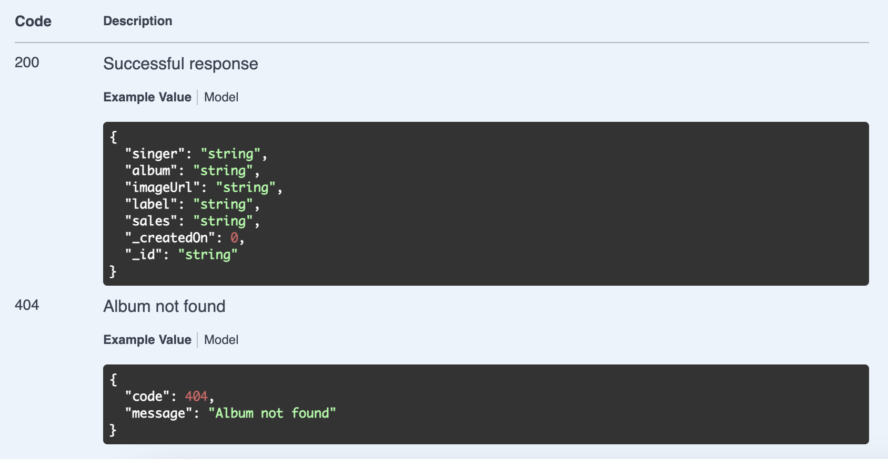

Update an Album
Authentication Required: This endpoint requires a valid user token. Please ensure you are authenticated by providing a token obtained from the login or registration process.
1. Locate PUT /data/albums/{id} :
- Find the PUT /data/albums/{id} endpoint in the Music Library Albums section.
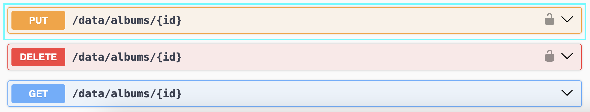
2. Expand PUT /data/albums/{id} :
- Click on the PUT /data/albums/{id} method to reveal the request form.
3. Enter the Album ID:
- Input the ID of the album you wish to update in the id path parameter field.
4. Fill in the Request Body:
- Provide the updated album details:
  - singer: Artist Name
  - album: Album Title
  - imageUrl: http://example.com/image.jpg
  - label: Record Label
  - sales: 1000
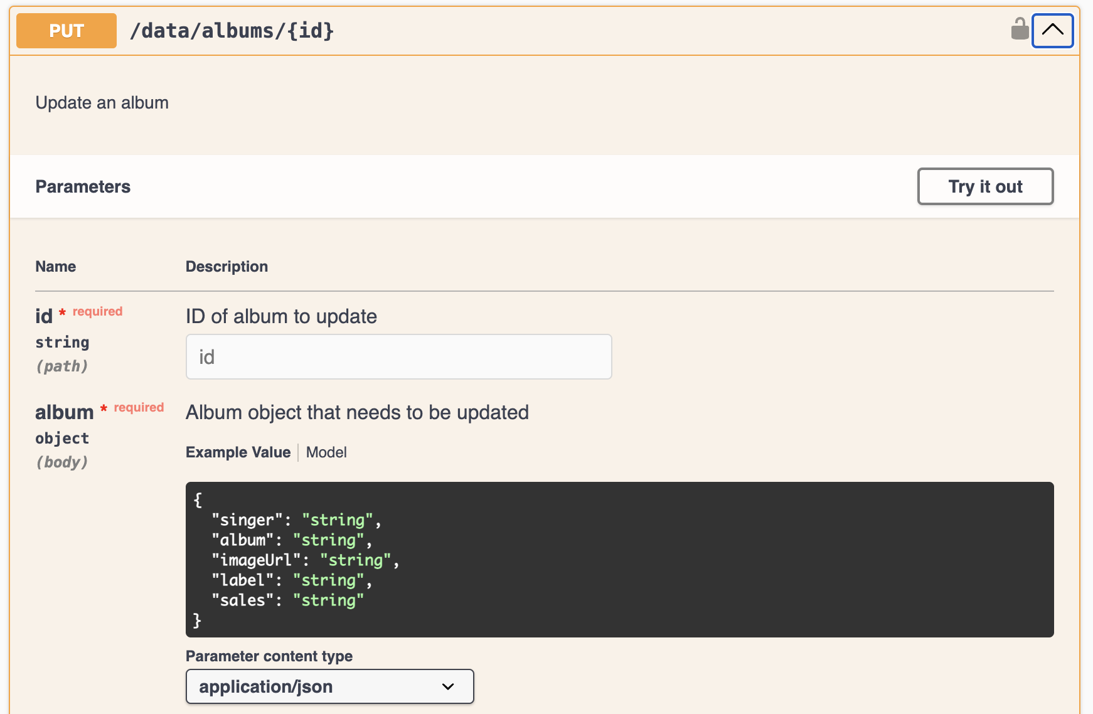
5. Send the request:
- Click the Try it out button and then click Execute to send the request to the server.
6. Review the response:
- Swagger UI will display the results of the request:
  - If successful (status code 200), verify that the album details have been updated.
  - If there is an error (status codes 401, 403, or 404), review the error message for details.
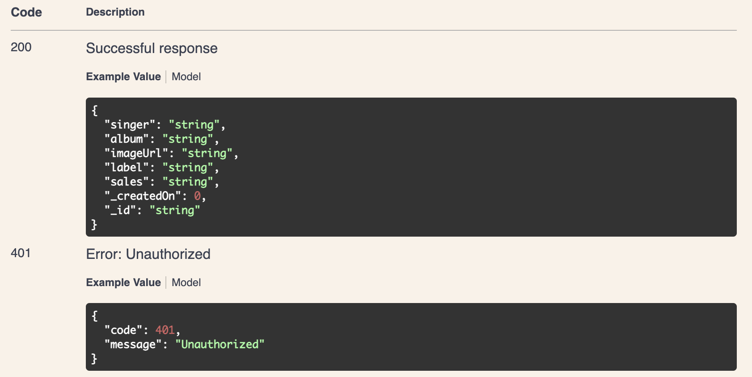
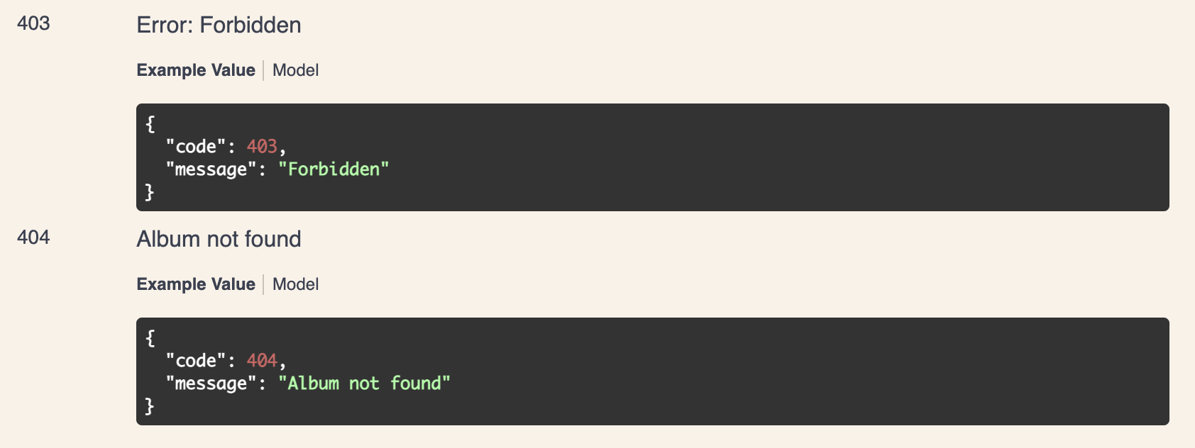

Delete an Album
Authentication Required: This endpoint requires a valid user token. Please ensure you are authenticated by providing a token obtained from the login or registration process.
1. Locate DELETE /data/albums/{id} :
- Find the DELETE /data/albums/{id} endpoint in the Music Library Albums section.
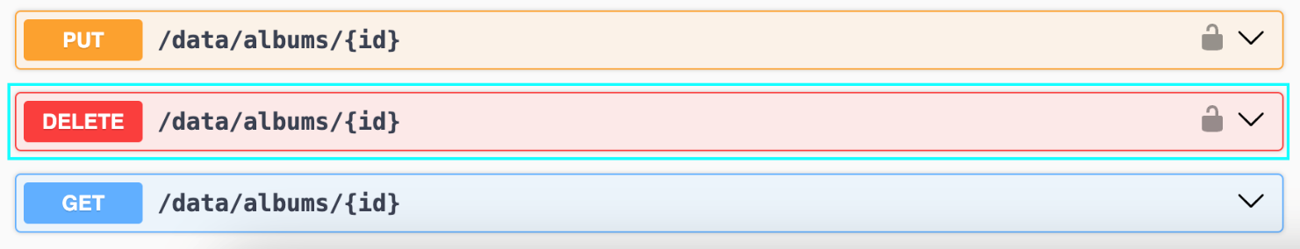
2. Expand DELETE /data/albums/{id} :
- Click on the DELETE /data/albums/{id} method to reveal the request form.
3. Enter the Album ID:
- Input the ID of the album you wish to delete in the id path parameter field.
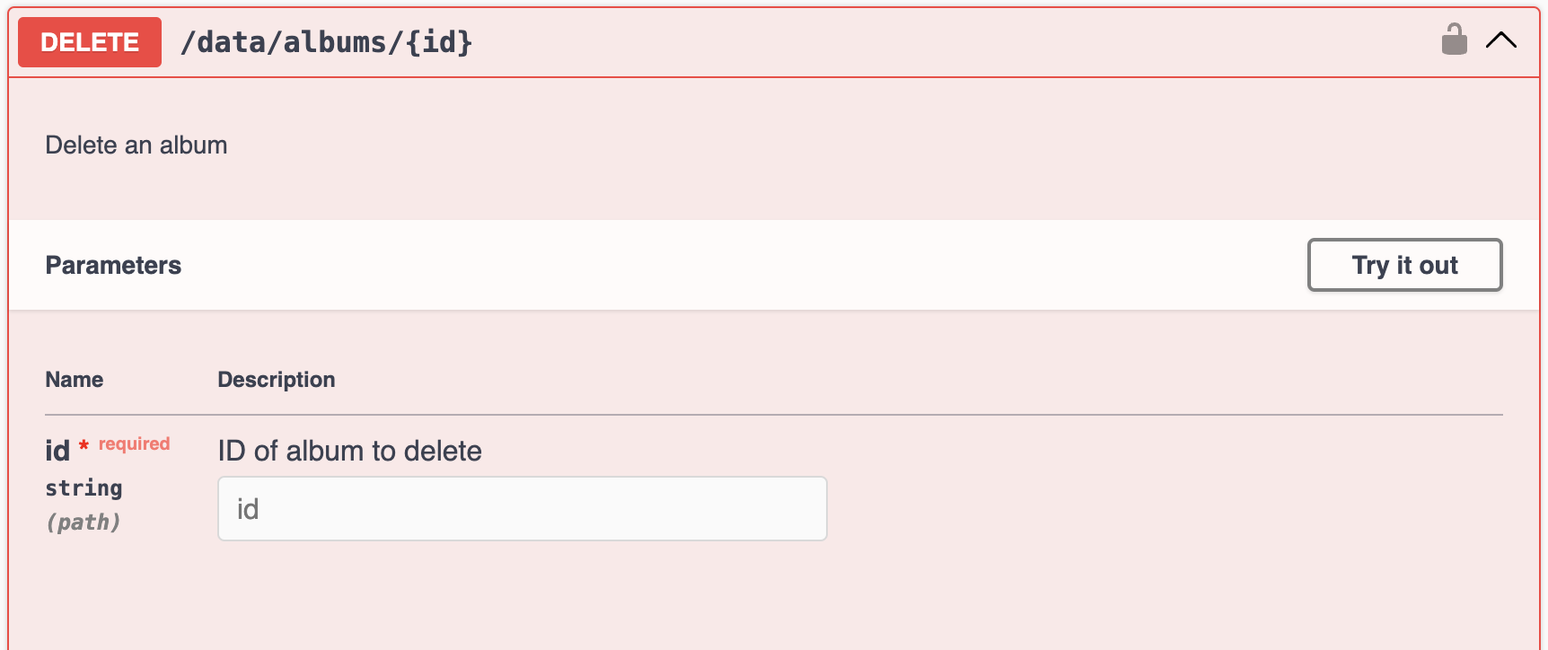
4. Send the request:
- Click the Try it out button and then click Execute to send the request to the server.
5. Review the response:
- Swagger UI will display the results of the request:
  - If successful (status code 200), verify that the album has been deleted.
  - If there is an error (status codes 401, 403, or 404), review the error message for details.
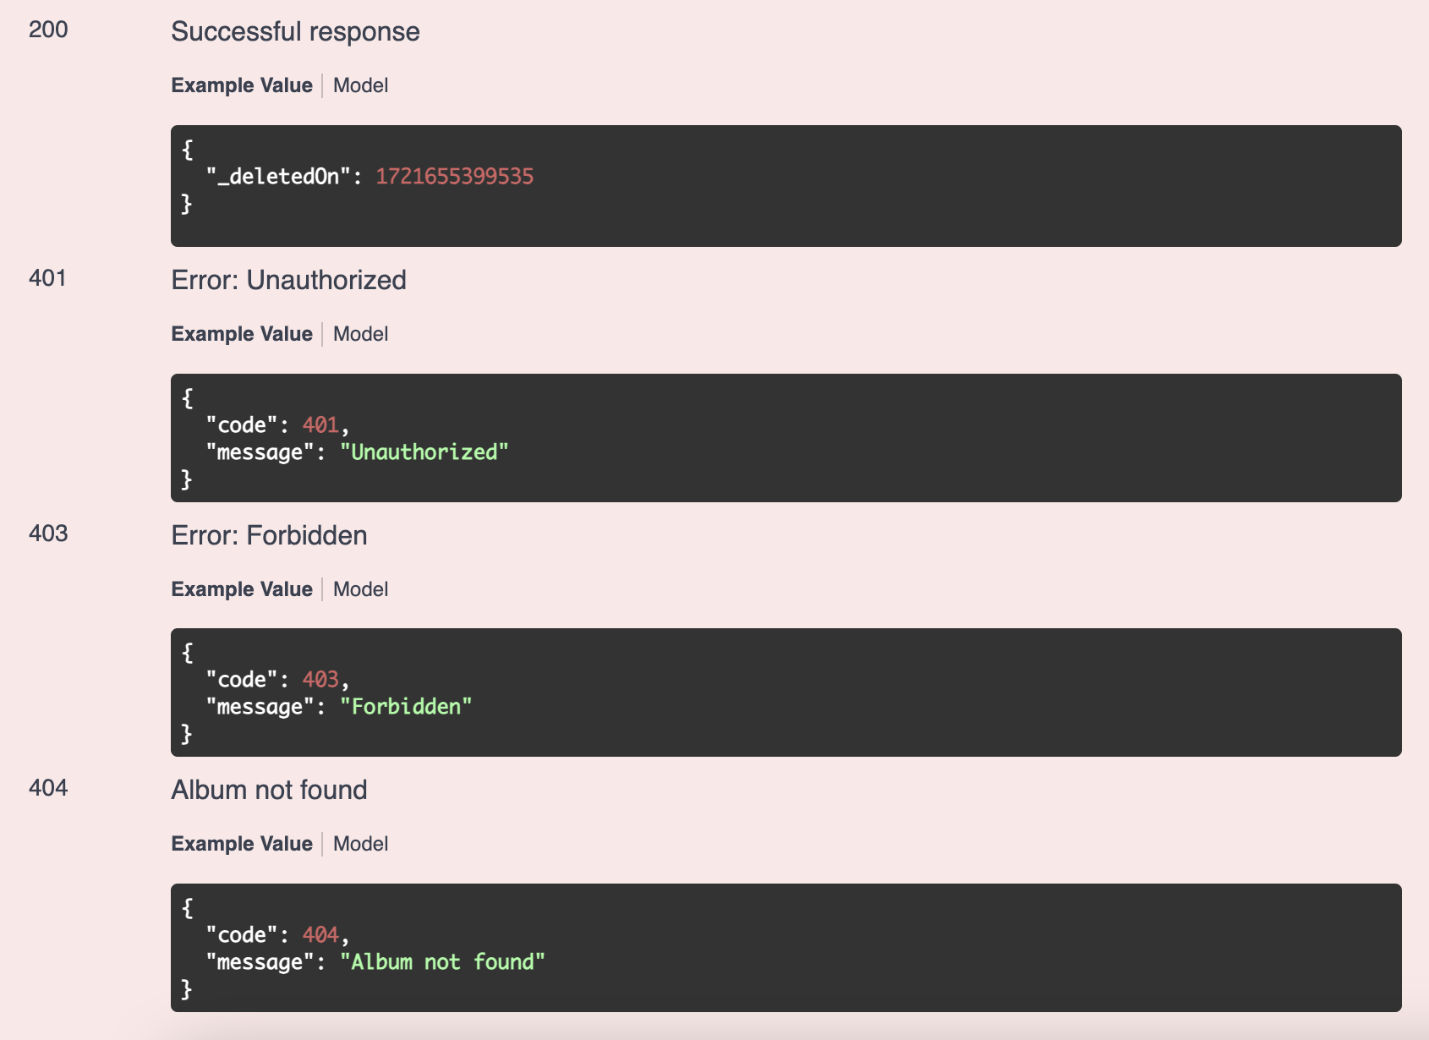
By following these instructions, you will be able to thoroughly test the API and ensure it meets the required functionality and performance standards. Happy testing!

Negative Testing

Try to Register Duplicated User
Receive 409 Error: Conflict

Register with Missing Password
Receive 400 Error: Bad Request

Login with Wrong Password
Receive 403 Error: Forbidden

Create Album without Token
Receive 401 Error: Unauthorized

GET Album by Fake ID
Receive 404 Error: Not Found

Data Ownership (User A vs User B)

User A
- Register + login
- Authorize token
- Create an album
- Save the returned _id (AlbumId) and _ownerId

User B
- Register + login with different email
- Authorize token for User B

Attempt ownership violation
- With User B token:
  - PUT /data/albums/{id} using AlbumId from User A
  - DELETE /data/albums/{id} using AlbumId from User A
Receive 403 Error: Forbidden

